**ONLINE BUS TICKETING RESERVATION SYSTEM**

**BY**

**FELIX MULINGE**

**ARSEL OTIENO**

**JUNE 2020**

# Acknowledgment

Our profound gratitude goes to God the creator of universe.

This work is a cooperation product of many minds and we feel a deep sense of gratitude to our parents for their encouragement for being ever supportive. Our sincere thanks, goes to our lecture Ms. Chebet for her thorough assistance with this work. We appreciate the effort and advice. We also acknowledge our fellow DIT students for their active verbal participation and suggestions towards the evolvement of this work.

We also appreciate the system developers who gave us a great hand of the entire scope of how the system should work.

# Abstract

Online Bus Ticket Reservation System is a Web based application that works within a centralized network. This project presents a review on the software program “Online Bus Ticket Reservation System” as should be used in a bus transportation system, a facility which is used to reserve seats, cancellation of reservation of different types of route enquiries used on securing quick reservations. OBTRS is built for managing and computerizing the traditional database ticket booking and tracking bus and travel mode. It maintains all customer details, bus details, reservation details. Structured System Analysis and Design Methodology [SSADM] will be adopted. In addition, PHP Hypertext Preprocessor [PHP] language will be used for the front- end of the software while the back end will be designed using MySQL. The software achieved will be capable of improving the customer hand and relationship management in operations. It is recommended that despite the present functionality of the designed software, an additional functionality such as the use of E-mail to send tickets and notifications to the customer and an online payment using credit card/debit cards and mobile money should be implemented into the system. Furthermore, other operations carried by the system such as the courier service should also be integrated in order to enhance the system.

**Table of Contents**

Acknowledgment ii

Abstract iii

Chapter 1 1

1.1 Introduction 1

1.2 Problem statements 1

1.3 Proposed solution 2

1.4 Objectives 2

1.5 General objectives 2

1.6 Specific objectives 2

1.7 Research questions 3

1.8 Time Plan 3

1.9 Budget Plan 4

Chapter 2 5

Literature review 5

2.1 INTRODUCTION 5

2.2 PURPOSE 6

2.3 SCOPE 6

2.4. CASE STUDY 7

2.5 Technique 10

2.6 Research 10

2.7 Web-based application 11

CHAPTER 3 12

3.0 METHODOLOGY 12

3.1 Description of Proposed System 12

3.2 System Requirement 12

3.3 System Development Tools 13

3.4 Requirement Specification 13

3.5 Functional Requirements 13

3.6 Non-Functional Requirement 14

3.7 Architecture of The Proposed System 14

3.8 The Functional Model of the System 15

3.8 User Activities 15

3.9 Administrator Activities 16

3.10 Data Flow Diagram 16

CHAPTER 4 18

SYSTEM ANALYSIS 18

4.1 Introduction 18

Functional requirement 18

Administrators 19

4.2.1.1 Bus Company Information 19

4.2.1.2 Bus Information 20

4.2.1.3 Member Account and Staff Profile 20

4.3 Non- functional requirement 20

Chapter 5 23

SYSTEM DESIGN 23

5.1 Introduction 23

26

REFERENCES 27

# Chapter 1

## 1.1 Introduction

The Online Bus Ticket Reservation (OBTR) system gives an authority to the customers to book tickets online and at the nearest booking counters to their respective destination.

An authorized staff will be able to log in and register a customer and then book the tickets.

The online bus ticket reservation system will be designed based on relational databases. The database will be maintained where the bus details along with the bus number, route, the places it covers throughout the distance and the timings will be registered.

Customer details entered at the time of booking need to be stored in the database so that the company can track the details of the customers later, and

employee details to be maintained in the database. Only an employee can book a ticket with the username and password. The list that is to be maintained is personal details, contact details, location, qualifications and age.

## 1.2 Problem statements

* Congestion of passengers in booking office
* leading to registration office using manual assigning of numbers which is a waste of time.
* Lack of immediate information storage- the information generated by various transactions takes time and efforts to be stored at a right file.
* Lack of prompt updating various changes to information like passenger details are difficult to make as paper work is involved.
* Inability to automatically schedule services, generate receipt and receive payments from passengers.
* Being unable to update the manual records.
* Preparation of accurate and prompt reports-this becomes a difficult task as information is difficult to collect from various books.
* Inability to retain records as they’re lost if they are kept on wrongly. E.g. change of office file storage.

## 1.3 Proposed solution

We have decided to take charge in designing a system that is friendly and will try to work out solution in a way that favors the interest of every customer and workers, solve error in transaction like calculation mistake and bill generation.

## 1.4 Objectives

The objective of online ticketing reservation system is to easily track the information of all customers, drivers, staffs and bus destination.

The main goal of the software is to build a good management tool for all customers. The main purpose of the software is to reduce time taken through manual system in order to maintain all the records.

## 1.5 General objectives

The main objective of this study is to develop an online bus ticketing reservation system.

## 1.6 Specific objectives

Some of the specific objectives of the system are listed below:

* To create a distributed system that will be used by the customers, to ensure that ticket reservation is easy and user friendly.
* To satisfy customer need by reaching them at their place.
* To reduce the work load of the ticket officers.
* To provide large number of tickets of reservation and cancelation services in a short time.

## 1.7 Research questions

1. What is the relevance of customer interaction in online ticketing reservation?
2. What are the effects of poorly designed system on user performance?

## 1.8 Time Plan

|  |  |  |  |  |  |  |
| --- | --- | --- | --- | --- | --- | --- |
|  | Responsibility | 1st week | 2nd week | 3rd week | 4th  week | 5th week |
| 1 | Proposal & introduction writing |  |  |  |  |  |
| 2 | Literature review |  |  |  |  |  |
| 3 | methodology |  |  |  |  |  |
| 4 | System analysis design and implementation |  |  |  |  |  |
| 5 | Conclusion |  |  |  |  |  |

## 1.9 Budget Plan

|  |  |  |
| --- | --- | --- |
| No | Particulars | Amount(kshs) |
| 1 | Internet service | 1500 |
| 2 | Transport | 2500 |
| 3 | Airtime | 500 |
| 4 | Stationery | 300 |
|  | **Total** | **4800** |

# Chapter 2

## **Literature review**

## **INTRODUCTION**

Richard Nordquist [2000] Defined literature review as the process of reading, analyzing, evaluating, and summarizing scholarly materials about a specific topic.

Based on Pedone (2001), widespread use of Internet has led to the emergence of a variety of electronic services, e-services. Electronic ticket, or e-ticket which is an example of such a class of e-services. E-tickets give evidence to their holders to have permission to enter a place of entertainment, use a means of transportation, or have access to some Internet services. Users can get the e-tickets by purchasing them from a web server, or simply receiving from a vendor, or from another user who previously acquired them. E-tickets can be stored in desktop computers or personal digital assistants for future use. For

some cases, like e-tickets non- transferable example e-ticket airline, it has to

be validated to prevent duplication, and ensure authenticity and integrity.

A user first has to relay it to server for validation before using an e-ticket. The validation process is called e-ticket problem, here, results in the server either accept or reject the e-ticket, and intended to prevent duplication which avoids multiple use of an e-ticket by the same or different users; ensuring authenticity and integrity that e-tickets are only accepted if they have been issued by an authorized source and have not been tampered with. In addition, for privacy, it is desirable that e-tickets should not contain any information associated with their holders.

Both specifications require e-tickets to be accepted exactly once in executions without failures. But the former specification may result in some e-tickets never being accepted or accepted multiple times in executions with failures.

There were a few protocols that can be used to solve the e-ticket problem, which are quorum-based e-ticket protocol, simple e-ticket protocol and the optimistic e-ticket protocol. Simple e-ticket protocol and the optimistic e-ticket protocol can be used to solve the at-most-once e-ticket problem.

## **2.2 PURPOSE**

Online bus ticket reservation system is web-based application whose purpose is to provide a facility of reserving a seat from anywhere.

# 2.3 SCOPE

The details of the buses, price list and seats available are to be maintained and can be updated regularly.

It also maintains the database that consists of the list of busses along with the five-digit code that will be assigned to each bus for easy reference.

Customer can reserve their seats; get the information of bus routes and in this way, you can reserve seats according to your requirements.

This system will provide a facility of cancellation of seats and different types of enquiry which need an instant and quick reservation.

There will be an update of cancellation of routes or any kind of problem.

# 2.4. CASE STUDY

In reference to Tod et at. (2000), a lot of problems that plague the entertainment sporting ticketing industry nowadays. Anyway, Generalized Estimating Equation (GEE) was developing its proprietary licensed approach for developing the ticketing solution of the future. But, some of the significant entertainment and sporting event ticketing

industry challenges GEE addressed while developing its solution.

The challenges are as below:

* Inefficient of primary sales channel for tickets to entertainment and sporting events.
* Lack of competitive pricing and competition in the industry.
* Dissatisfaction of patron with today's ticketing options and costs.
* Lack of ticketing alternatives and options for today's users of ticketing services and products.
* Tickets become a barer bond commodity type of asset the second they are printed, resulting in potential theft, loss and counterfeit to the patron, and
* lost income, information and theft for the event sponsor.
* To control illegal ticket trading activities by ticket brokers and all the ticket scalpers, law enforcement agencies are being challenged.
* Limited access to popular events by event patrons.
* Because of the fragmentation of the seller market, a true market value is difficult to determine.
* Inefficient initial pricing of tickets resulting in significant queuing issues for popular events and empty venues for less popular events.
* Barer bond business model of physical tickets influences it difficult and challenging to sell or transfer tickets to other patrons on short notice for many corporate ticket owners, as well as certain individual ticket owners.
* The over pricing of tickets for many events will influence foregone revenues from both ticket sales for parking, concessions and merchandise.
* Patrons have little to no seating flexibility under today's business model.
* Patrons have little to no seating flexibility under today's business model.
* Paper tickets have tremendous risk of theft, loss, counterfeiting and are simply expensive to manufacture and distribute nowadays.

Computers and Internet are changing commerce. This is because goods and services that are sold in stores, through mail order, or via the telephone are today also bought and sold through various forms of e-commerce. E-Bay, u-Bid, and Bid.com represent one of the most successful categories of commerce in the Internet- based auction site. Besides that, another new form of commerce is the so-called "buyer driven commerce" or "reserve shopping. For this type of

commerce, buyers have to inform vendors what products or services they want to purchase and how much they are willing to pay for them. The successfully reception of these new methods for buying and selling goods confirms that people are receptive to new ways of buying and selling goods and services. So, GEE'S proprietary model for selling and trading eTickets is ideally suited to exploit this receptiveness. A11 these new technologies should be used to more efficiently determine optimal offer prices. To determine what price to offer, buyers can now readily locate products at desire prices or consult market benchmarks. If you can't manage prices, you have to make risky decisions about cost cutting, the use of new technology, increasing productivity, and introducing innovative products and services to give yourself a cushion in the event that your pricing gets weaker. (Edward, 2000) Nowadays, clients and patron really

dissatisfaction with existing ticket agents. They feel unhappy with the poor service and high fees charged by current third patty ticketing agents. Besides

that, patrons have been started by an inability to purchase tickets because of

busy telephones, excessive traffic on the ticket agent's website, or lack of

ticket inventory available. Because of that, e-Market places are being created

within most industries, attacking outdated business practices and inefficient trading relationships. Besides, the number of online investors is rising rapidly

because online stock trading is more convenience, ease of use, lower

commissions and control. Further more, there was number of recent industries

developments and practices lend further support to GEE's licensed services. The developments are ticket exchange for bar coded tickets, dynamic consumer driven pricing for tickets and use of eTicket forms for entertainment

and sporting events. For example, Encryptix.com is appears to be targeting markets very similar to GEE and is initially using bar code tickets that can be

printed on any printer as their preferred medium for electronic tickets. From statistic that have been done, online ticketing industry is growing at 67%, albeit, from a fairly small case. GEE's management believes that the total size of the e-Ticket market will significantly expand through the use of the Company's

licensed services with the introduction of free market principles and inclusion

of a dynamic secondary trading market for eTicket.

# 2.5 Technique

The approaches and techniques that are used for the new system are web based

application and research.

# 2.6 Research

A useful fact and finding are to research the application and problem. Computer trade journals, reference books and the Internet are good sources of information. They can provide information on how others have solved similar problems, plus can learn whether or not software packages exist.

To solve the problem. The advantages and disadvantages of using research

as a fact and finding.

**Advantages and disadvantages**

|  |  |
| --- | --- |
| **Advantages** | **Disadvantages** |
| **-**can save time if solution already exist. | -can be time-consuming. |
| **-**researcher can see how others have solved similar problems or met similar requirements. | **-**requires access to appropriate sources of information. |
| **-**keeps researcher up to date with current developments. | -may ultimately not help in solving problem because problem is not documented elsewhere. |

# 2.7 Web-based application

In software engineering, a web-based application-sometimes called a webapp and much less frequently a web application-is an application that is accessed with a

web browser over a network such as the internet or intranet. Web applications are popular due to the ubiquity of the browser as a client, sometimes called a thin client. The ability to update and maintain web applications without distributing and installing software on potentially thousands of client computers is a key reason for their popularity. Web applications are used to implement web mail, online retail sales, online auctions, wikis, discussion boards, web logs, MMORPGs, video logging and perform many other functions.

Therefore, the web-based application is chosen in the development of this system.

# CHAPTER 3

## 3.0 METHODOLOGY

## 3.1 Description of Proposed System

The system is very simple in design and to implement. The system requires very low system resources and the system will work in almost all configurations. It has got following features:

• It will ensure data accuracy.

• Records will be efficiently maintained by DBMS.

• Availability of seats can be enquired easily.

• Passengers can also cancel their tickets easily.

• Minimum time needed for the various processing.

• It will provide better Service.

Shuchi, G. (2008) stated that system design is to create a technical solution that satisfies the functional requirements for the system. At this point in the project life cycle there should be a Functional Specification, written primarily in business terminology, containing a complete description of the operational needs of the various organizational entities that will use the new system. The challenge is to translate all of this information into Technical Specifications that accurately describe the design of the system, and that can be used as input to System Construction.

## 3.2 System Requirement

The requirement definition is concerned with the analysis of the existing system with the aim of determining and structuring the requirement of the proposed system. It is achieved with the aid of user requirement. The Analysis stage was specifically carried out in focus of the functionality dataflow at Young Legacy Line Transport Division.

## 3.3 System Development Tools

this project will be a web application to be developed in PHP having:

* Database design (MySQL)
* Form design (HTML)
* Coding (php)
* Testing (WAMP SERVER)
* Reporting tool

## 3.4 Requirement Specification

Requirement Specification a complete description of the behavior of a system to be developed and may include a set of use cases that describe interactions the users will have with the software. In addition, it also contains nonfunctional requirements. Non-functional requirements impose constraints on the design or implementation (such as performance engineering requirements, quality standards, or design constraints)

## The Functional Model of the System

UML use case diagram of the bus reservation system is shown in the diagram below. In this figure, details of the various participants are also detailed

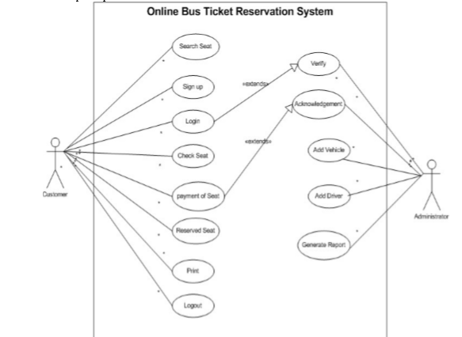

## **3.5 Functional Requirements**

Functional requirements define the specific functions that the system performs, along with the data operated on by the functions. The functional requirements are presented in scenarios that depict an operational system from the perspective of its end users. Included are one or more examples of all system features and an enumeration of all the specific requirements associated with these features.

• The system shall incorporate mechanism to authenticate its users

• The system shall verify and validate all user input and should notify in case of error detection and should help the user in error correction

• The system shall allow sharing of files in the system

• The system shall allow quick messages to be exchanged without face to face interaction

## 3.6 Non-Functional Requirement

Non-functional requirements address aspects of the system other than the specific functions it performs. These aspects include system performance, costs, and such general system characteristics as reliability, security, and portability. The non-functional requirements also address aspects of the system development process and operational personnel. It includes the following:

• The system shall be user friendly and consistent.

• The system shall provide attractive graphical interface for the user.

• The system shall allow developer access to installed environment.

• The system shall target customer base.

## 3.7 Architecture of The Proposed System

This process supports existing infrastructure requirements and provides specific recommendations for hardware and network solutions based on existing and projected user needs. Application requirements, data resources, and people within an organization are all important in determining the optimum hardware solution. It is represented using a three-tier architecture that comprises of user interface, process management and Database Management System (DBMS). It shows the components of the system, the services they provide and the way they communicate to bring about the system functionality.

## 3.8 The Functional Model of the System

UML use case diagram of the bus reservation system is shown in the diagram below. In this figure, details of the various participants are also detailed



## 3.8 User Activities

The most common activities carried out by user are illustrated bellow

• The user can search for the seat

• The user can sign up/do registration with the system

• The registered user can login to the proposed system

• The user can check for the available seat

• The user can also do payment for the seat on the proposed system

• The user can print receipt on the system as evidence of payment

## 3.9 Administrator Activities

• The administrator will verify all the registered user, and allow them to login to the system

• The administrator gives acknowledge to any payment user made on the system

• The administrator can add vehicle, driver and generate report as well

## 3.10 Data Flow Diagram

Data flow diagram is used to show the flow of data from external entities into the system. It is used to represent the physical and logical area of an information system. The data flow diagrams are pictorial or graphical representation of the Online Bus Ticket Reservation System. The data flow diagram covers all the processes and data storage area, which takes place during any transaction in the system.

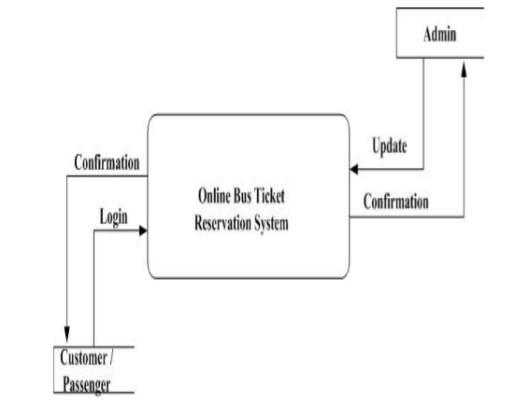

# CHAPTER 4

# SYSTEM ANALYSIS

## 4.1 Introduction

System Analysis is a phase which is conducted before the development of the Online Bus Ticketing Reservation System web portal. System Analysis shows the requirement or a description of the needs and desires for an information system. A requirement may describe functions, features, and constraints. Thus, system requirement defines the services provided by the system and prescribes constraints for its operation. There are two types of requirement, functional requirement and non-functional requirement. In efforts to improve the existing bus e-ticketing systems in Kenya, observation on the problems and opportunities from the existing e-ticketing sites both in Kenya and overseas has been conducted. With this, we have recommended an integrated system of solutions that attempts to rectify many of the existing problems in the current bus e-ticketing and propose an innovative way to enhance the services provided in the bus e-ticketing system.

## Functional requirement

Functional requirement is a function or feature that must be included in an information

system to satisfy the business needs and user acceptance. System administrators and Customers (members and non-members) will use this proposed Online Bus Ticketing Reservation System web portal. A clear and detail functional system requirements for this system of both the Administrator section and Customer section are described as following.

## Administrators

The System Administrator can access all the functions in this system, which includes the bus operator information module, bus information module, member and staff account module, purchasing and cancellation module and the reports module. There will also be an Authority module which can only be accessed by an authorized governing body personnel. The functional requirements for the administrators’ section are as following

### 4.2.1.1 Bus Company Information

(a) Home

This is the home page of the administrator section which displays the company profile and also the promotions that is currently available.

(b) Feedback

The system administrator can view, add, edit, search and delete the feedbacks given by the users. These feedbacks included the suggestion or comments given by the customers and the administrator can reply these feedbacks by uploading the feedbacks on the website.

(c) Forum

The administrators are allowed to view and post message to the discussion area (containing post and reply messages) for customers to express their interests and opinions.

(d) Frequent Asked Questions (FAQ)

The system administrator can view, add, edit, search and delete the company’s FAQ. The FAQ includes the information about payment method, the maximum seat can be booked, the company’s web transaction security and so on.

(e) Latest News

The system administrator can view, add, edit, search and delete the company latest news. These latest news includes the changes of the departure time for a particular trip, the information about the extra trip during the peak season, the changes of fare rates and so on.

## 4.2.1.2 Bus Information

The system administrator can view, add, edit, search and delete the company’s bus

information. The bus information includes bus type, bus registration number, total seat of

bus, departure time, bus destination, bus departure date, and so on.

### 4.2.1.3 Member Account and Staff Profile

(a) Member Account

The member account includes the registered member profile. The system administrators are authorized to view and search the member profile. The member profile includes the member’s name, member ID, age, occupation, address, telephone number, e-mail address and so on.

(b) Staff Profile

The system administrator can view, add, edit, search and delete the bus operator’s staff profile. The bus operator’s staffs are the administrators, counter clerks, managers, officers and so on. The staff profile includes their name, position, age, address, e-mail address, telephone number and so on will be stored in database

## 4.3 Non- functional requirement

Non-functional requirement is a description of the features, characteristics, and attributes of

the system as well as any constraints that may limit the boundaries of the proposed solution.

Such constraints usually narrow down the selection of programming language, operating

system platform or implementation techniques. The Online Bus Ticketing Reservation System web portal will ensure certain web application qualities. Such as ease of use, user-friendliness, correctness, functionality, reliability, response time, security, robustness as well as maintainability. The following lists the non-functional requirement of the system.

1. Ease of Use

The system should be simple and easy to use. Documentation and user manual should be

provided to the users, to ensure that the users are able to use and operate the system by

themselves. Help sections or user instructions should also be provided throughout the system

in order to guide users when they encounter any problems.

(b) Maintainability

Maintainability is the ease with which a program can be corrected if an error is encountered, adapted if its environment changes, or enhanced if the customer desires a change in requirement. In order to make the system easily maintained, the programs must be easily understandable by the maintenance programmer and easily modified and tested when updating is done to meet new requirements, rectifying a deficiency or correcting errors.

(c) Reliability

Reliability is the extent to which a program can be expected to perform its intended

function with requirement precision. This system should be reliable, where it does not produce dangerous or costly failure when it is used in a reasonable manner. Furthermore, this system should perform all its services and functions accurately and in timely manner. This quality is essential as it indicates how far users will have confidence in the implementation of this Online Bus Ticketing System web portal.

(d) Robustness

Robustness refers to the ability of the system to be able to handle or continue in operation when faced with unexpected circumstances such as handling improper data. The system should be robust enough to handle anticipated or unanticipated error.

(e) Response Time / Speed

The system should be able the process any transaction at the highest speed and avoid unnecessary interaction. As a low response time, the users may feel frustrated and decide not use this system.

(f) Security

This system should have security measures to minimize the risk of data exposure to unauthorized people. Only the authorized users with the correct login and password are allowed to access and manipulate the data kept in the database.

(g) User-Friendly

A user-friendly interface enables the users who are with or without technical background able to operate and use this system. A user-friendly system will satisfy users and allow interaction with this website and able to utilize this system to the maximum.

(h) Functionality

The most important function stressed in this system is the searching and retrieving capability. This is because the web application deals with data retrieval from the existing database. Besides, manipulation and browsing features as well as applications domain-related features is also taken into account.

(I) Correctness

Correctness refers to the degree to which the software performs its required function. Thus, programs for the system must be operating correctly for the user to retrieve the desired outputs. To ensure this system quality, numerous testing and trail-and-errors is carried out.

# Chapter 5

# SYSTEM DESIGN

# 5.1 Introduction

This chapter is on system design which is completed before the development of the Online

Bus Ticketing System web portal. System design is defined as those tasks that focus on the

specification of the detailed computer-based solution. The purpose of the design phase is to transform the system requirements statement from the requirements analysis phase into design specifications for construction.

5.2 Purpose

The document is designed to be a reference for any person wishing to implement, or any persons interested in the design architecture of OBTRS (online bus ticketing reservation system). This document describes each application’s architecture of design interface of logical interface and physical interface design. This design will detail the implementation of the requirements.

5.3 System Overflow

This document will include but is not limited to the following information for OBTRS;

Design considerations, architectural strategies, system architecture, high level design context diagram and use case diagram and detailed level design consist of data flow diagram level 1 and sequence diagram and Entity relationship diagram.

5.4 System scope

Main inputs

1. Passenger name
2. Seat booking passenger ID
3. Passenger address, phone number, gender
4. Departure date and time

Main outputs

1. Seat booking interface
2. Departure configurations details

Software will be designed to allow users perform following functions

1. Log on either as system administrator or as a system user.
2. Add passenger into system
3. Update or delete record information depending on the user authorization level

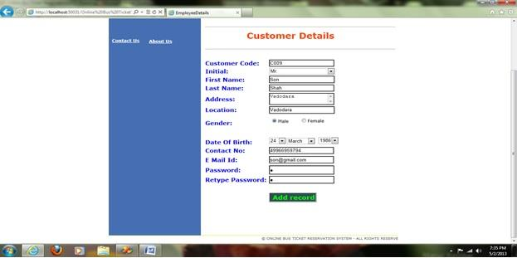

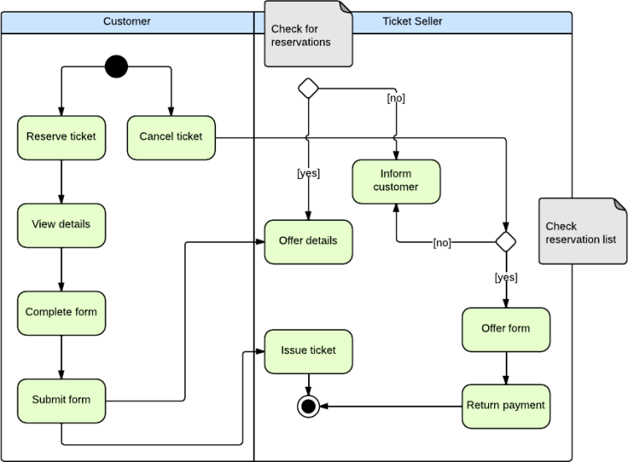

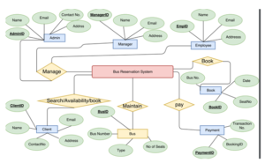

CUSTOMER SECTION

CUSTOMER SECTION

CUSTOMER SECTION

CUSTOMER SECTION

CUSTOMER SECTION

USER POLL

CUSTOMER SECTION

# REFERENCES

**SIVAKUMAR DURAISAMY: “ Android app for online ticketing ”**

**Department of Computer Engineering, University of Pretoria, Private Bag X20 Hatfield 0028 SA: ”** Development of an Online Bus Ticket Reservation System for a Transportation Service in Nigeria**”**

**Department of Computer Engineering, KBTCOE, Nashik – 422013, Maharashtra, India;**

**nuke.2050@gmail.com, [dipikatidke@kbtcoe.org](mailto:dipikatidke@kbtcoe.org). “**Online Bus Tracking and Ticketing System**”**

**MELISA KAUR A/P NARJAN SINGH: ”** A STUDY AND DEVELOPMENT OF AN ONLINE BUS TICKETING SYSTEM”

## 